16.13: The mass per unit length is related to the density (assumed uniform) and the cross-section area 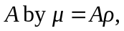so combining Eq. (15.13) and Eq. (16.8) with the given relations between the speeds,

